- What is the best advice to a driver that has been drinking alcohol?
A. To drink less than an hour before the drive.
B. To arrange for a designated driver, use public transportation or call a cab.
C. To eat more while drinking.
D. To drink black coffee.

Comment:
Social drinking frequently leads to impaired driving. If you are going to drink, do not drive. If you are going to drive, do not drink.
Some alternatives to driving impaired are:
- Designate a driver.
- Call a taxi.
- Call a friend.
- Stay overnight at a friend's house.
Remember, drinking coffee, exercising, taking cold showers, and similar do not increase the rate of oxidation. Only time can sober a person who has been drinking.

- Which sign tells you that there is an undivided roadway with two-way traffic ahead?
A. 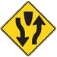
B. 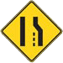
C. 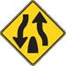
D. 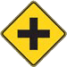

Comment:
Divided Highway Ends.
The divided road ends ahead. Two-way traffic will no longer be divided by a center island. You will be on an undivided roadway with two-way traffic. Keep to the right.
If you got this question wrong, look at the divider or median on the sign. If it is located at the bottom, it means that you are leaving a divided highway. When the divider is located at the top of the sign, it means that you are approaching a divided highway.

- 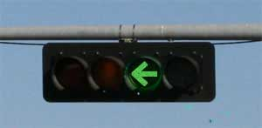
A traffic light with a green arrow indicates that:
A. All other vehicles and pedestrians have a red light.
B. Oncoming traffic is stopped by a red light.
C. You can make a safe turn without checking other traffic.
D. None of the above.

Comment:
A green arrow means you can safely turn in the direction of the arrow. Your turn should be protected from oncoming or crossing traffic (A protected turn).
Remember, it does not mean that all other traffic is stopped by a red light

- When making a right turn you should not:
A. Drive close to the right edge of the road.
B. Honk your horn to warn pedestrians within the crosswalk.
C. Yield to pedestrians and bicyclists.
D. Signal at least 100 feet before the turn.

Comment:
You should not honk your horn to warn pedestrians within the crosswalk.
After checking traffic behind you and signaling your intent, move close to the right curb. Look right and left before beginning the turn. Yield right of way, if necessary. Turn the steering wheel hand-over-hand, and complete the turn in the lane next to the curb.
This question asked what you should NOT do.

- Which sign tells you that you must turn left or right on the road ahead?
A.
B. 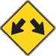
C. 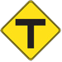
D. 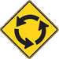

Comment:
T-Intersection Ahead.
The road you are traveling on will end soon. Prepare to turn right or left. Yield to cross traffic.

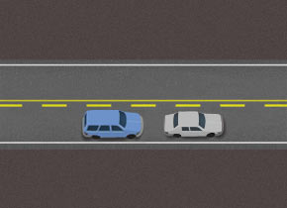
- If you are being tailgated on a two-lane two-way road, you should:
A. Drive on the shoulder to encourage the tailgater to pass.
B. Turn on your emergency flashers to alert the driver behind you.
C. Wait until passing is possible, and then slowly reduce speed.
D. Speed up, to avoid getting hit from behind.

Comment:
If the vehicle behind you is following too closely, wait until the road ahead is clear and passing is legal, then slow down slightly and allow the other vehicle to pass.
Never slow down quickly to discourage a tailgater. All that does is increasing your risk of being hit from behind.

- If you have a tire blowout while driving, you should:
A. Immediately step hard on the brakes.
B. Continue driving until you get to an auto repair and service shop.
C. Steer straight ahead until your speed is safe for driving off the pavement.
D. Immediately steer off the road.

Comment:
If you experience a blowout, hold the steering wheel tightly, steer straight ahead, and slowly ease your foot off the accelerator. Do not brake until the vehicle is back under your control. Then, pull the vehicle completely off the road at the nearest safe location.

- Which sign tells you must pass to the left of an obstruction?
A. 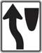
B. 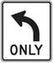
C. 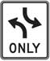

Comment:
Keep Left.
Stay to the left of a traffic island, median, or obstruction ahead.

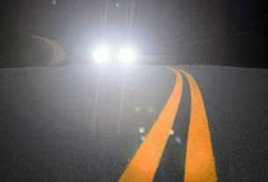
- To avoid glare from high-beam headlights of an approaching car:
A. Look to the right side of the road.
B. Focus on the center line on the road.
C. Look straight ahead until your eyes recover from the glare.
D. Flash your high beams.

Comment:
If you are blinded by glare, use the white line along the right edge of the road as a reference. This will allow you to see enough of the edge of the road to stay on course until the other vehicle has passed.

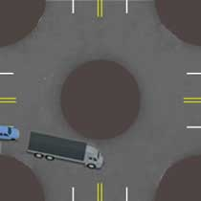
- When you approach a truck in a multi-lane roundabout, you must:
A. Stay behind.
B. Pass on the right.
C. Pass on the left.
D. Honk your horn before passing.

Comment:
Do not stop, pass or change lanes within a roundabout.
Remember, large vehicles need more space in a roundabout. Avoid driving next to large trucks while maneuvering through a roundabout.

- Why is it important to know what kind of braking system your vehicle has?
A. You might be asked by a police officer.
B. Your safety depends on knowing how to use the system.
C. It affects your insurance.

Comment:
Knowing how to apply your brakes in an emergency situation may save your life. It is important to read the owner's manual of your vehicle to learn the safe and proper operation of your brake system.

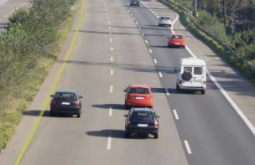
- When driving on a limited-access roadway with several lanes, you should avoid:
A. Driving in the middle of your lane.
B. Staying at least three seconds behind the vehicle ahead of you.
C. Adjusting your speed to allow others to enter the highway safely.
D. Using the middle or left-hand lane if you are traveling slower than other traffic.

Comment:
Do not use the middle or left-hand lane if you are traveling slower than other traffic. It is unsafe and may also be illegal.
If you are driving at a slower speed than other traffic, stay in the lane nearest to the right side of the road.
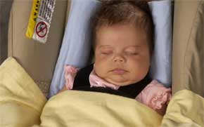
- What is a suitable restraint system for a child weighing less than 20 pounds?
A. A rear-facing infant car seat.
B. A booster seat.
C. A safety belt.
D. An adult holding the child.

Comment:
Infants must ride in a rear-facing child safety restraint system until they are at least 1 year of age and weigh at least 20 pounds.
However, according to the American Academy of Pediatrics, children should ride in a rear-facing child safety system until they are at least 2 years of age.

- To qualify and obtain an instruction permit you must be at least:
A. 15 years.
B. 15 years and six months.
C. 14 years and six months.
D. 16 years.

Comment:
To qualify and obtain an instruction permit you must be at least 15 years of age.

- If you need to use hand and arm signals, how would you signal a right turn?
A. Extend left arm downward, with palm of hand to the rear.
B. Extend left arm and move it up and down.
C. Extend left arm, with elbow bent upward.
D. Extend left arm horizontally.

Comment:
Right turn - left arm extended, with elbow bent upward, at about a 90-degree angle.

- If you are caught driving in excess of 100 mph your driving privileges will be:
A. Revoked for 90 days.
B. Suspended for 30 days.
C. Revoked for a minimum of six months.
D. Suspended for up to one year.

Comment:
If you are caught driving in excess of 100 mph your driving privileges will be revoked for a minimum of six months.

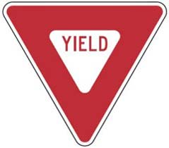
- Know signs by their shapes. The equilateral triangle shape is used for:
A. General warning of possible hazards.
B. Railroad advance warning signs.
C. Stop signs.
D. Yield signs.

Comment:
Three-sided red yield signs mean you must slow down to a speed reasonable for the conditions and yield the right-of-way. Stop if necessary.

- When should you use your parking lights?
A. If weather conditions require you to use your windshield wipers.
B. At night and when approaching another vehicle from behind.
C. When driving in a fog.
D. None of the above.

Comment:
Whenever it is necessary to drive with your lights on, you must use your headlights. Parking lights are for parked vehicles only.

- A truck driver's blind spots are larger on:
A. The left side of the truck.
B. The right side of the truck.
C. Left and right are equally large.

Comment:
Be particularly conscious of blind spots when driving near commercial vehicles. There are several no-zones (blind spots) in which a driver cannot see other vehicles. These areas include rear, front, and both sides of a commercial vehicle - especially on the right side!.

- When you park on a hill headed downhill and there is no curb, you should turn your front wheels:
A. Toward the side of the road.
B. Parallel to and by the side of the road.
C. Parallel to and at least 12 inches away from the side of the road.
D. Away from the side of the road.

Comment:
Headed downhill with no curb, turn the wheels to the right or side of the road, so the car will roll away from the center of the road if the brakes fail.
Remember, when you park on a hill, the general rule is turning your wheels sharply towards the side of the road or curb. This way, if your vehicle starts to roll downhill, it will roll away from traffic. However, when headed uphill at a curb, you should turn the front wheels in the opposite direction, away from the curb and towards the road. Then, let your vehicle roll backwards until the back of your front wheel touches the curb. The curb will stop your car from rolling into traffic.

- What type of pavement marking separates lanes with traffic going in the same direction?
A. Yellow dashed lines.
B. White lines.
C. Solid yellow lines.
D. Red lines.

Comment:
White lines separate lanes of traffic traveling in the same direction.

- When an emergency vehicle using flashing lights approaches you from the opposite direction on a four-lane limited-access highway with a center median, you should:
A. Proceed as normal, but be extra alert.
B. Pull over to the right edge of the roadway and stop.
C. Drive to the right edge of the road and slow down.

Comment:
You are not required to stop if the emergency vehicle that is approaching you is separated from your lane of traffic by a physical barrier such as a fence, wall, or median strip. Proceed as normal, but be extra alert.

- If your car stalls on railroad tracks and a train is approaching, you should:
A. Stay beside the car, but clear of the tracks.
B. Walk quickly away from the tracks and towards the train.
C. Walk quickly in the same direction as the train, staying clear of the tracks.
D. Walk quickly in the direction that you were traveling.

Comment:
If your vehicle becomes stalled on railroad tracks and a train is approaching, leave the vehicle. Keeping a safe distance from the tracks, walk quickly in the direction from which the train is approaching to avoid being struck by debris from the collision.

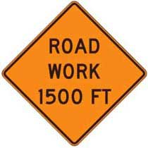
- Know signs by their standard colors. Orange is used for:
A. General warning.
B. Construction and maintenance warning.
C. Stop or prohibition.
D. Motorist services guidance.

Comment:
Orange is used as a background color for construction and maintenance warning signs. They alert you to possible dangers ahead due to construction and maintenance projects.

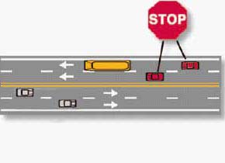
- When approaching a stopped school bus with flashing red lights traveling on your side of an undivided highway with four or more lanes, you must:
A. Pass as quickly as possible.
B. Stop.
C. Stop, but only as long as there are children crossing the street.
D. Slow down and proceed with caution.

Comment:
When a school bus is stopped with its red lights flashing and its stop arm extended, you must stop your vehicle at least 20 feet from the bus. Oncoming traffic and motorists approaching the bus from behind may not move until the stop arm is retracted and the red lights are no longer flashing.
It is illegal to pass a school bus when its red lights are flashing and its stop arm is extended.

