Name: _________________

A. 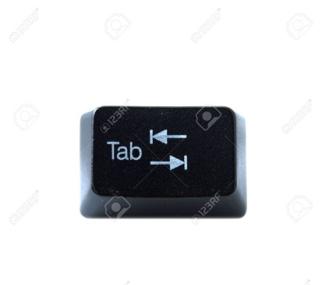 1.) Delete things to the left of the cursor.
B. 2.) Start typing on a new line.

C. 3.) Moves the cursor up one line.

D. 4.) Takes you to the next tab stop.

E. 5.) Press together with “c” to copy.

F.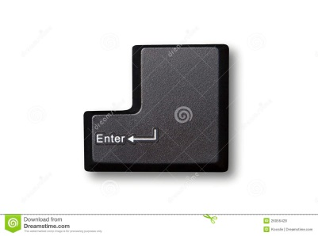 6.) Make all capital letters.

G. 7.) Helps you to make a question mark.

