Volume Setting

- Click on 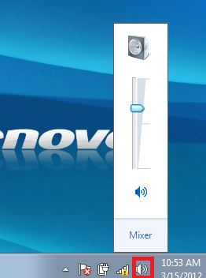

- Control Volume, click and hold bar. 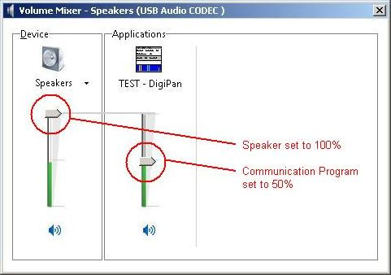

- To mute or unmute, click on 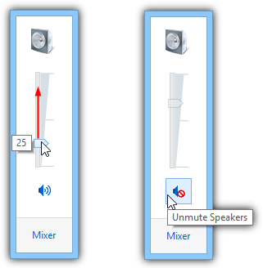

Now you try!!

- Set your volume high to 100
- Set your volume low to 1
- Set your volume to 50
- Set your volume low to 25
- Set your volume high to 75
- Set your volume low to 5
- Set your volume high to 95
- Set your volume to mute
- Set your volume to unmute
- Set your volume to any number.

